UMAX commentary –February 2020 (January Option Period)
Adviser Use Only

UMAX: ASX
NAV per unit (January 17) | $ 21.4132
NAV per unit (December 20) | $ 21.1772
January Option Period Returns
UMAX Total Return |  | 2.52%
S&P 500 Total Return |  | 3.83%
Over (Under) Performance |  | -1.31%
January Options at Inception
1-Mth Implied Vol. |  | 9.7%
Portfolio Delta |  | -0.24
% Portfolio Written |  | 97%
February Options at Inception
1-Mth Implied Vol. |  | 9.5%
Portfolio Delta |  | -0.25
% Portfolio Written |  | 97%
Distribution Per Unit History (by ex-date)
2 January 2020 |  | $0.2889
1 October 2019 |  | $0.2615
1 July 2019 |  | $0.2826
1 April 2019 |  | $0.3117
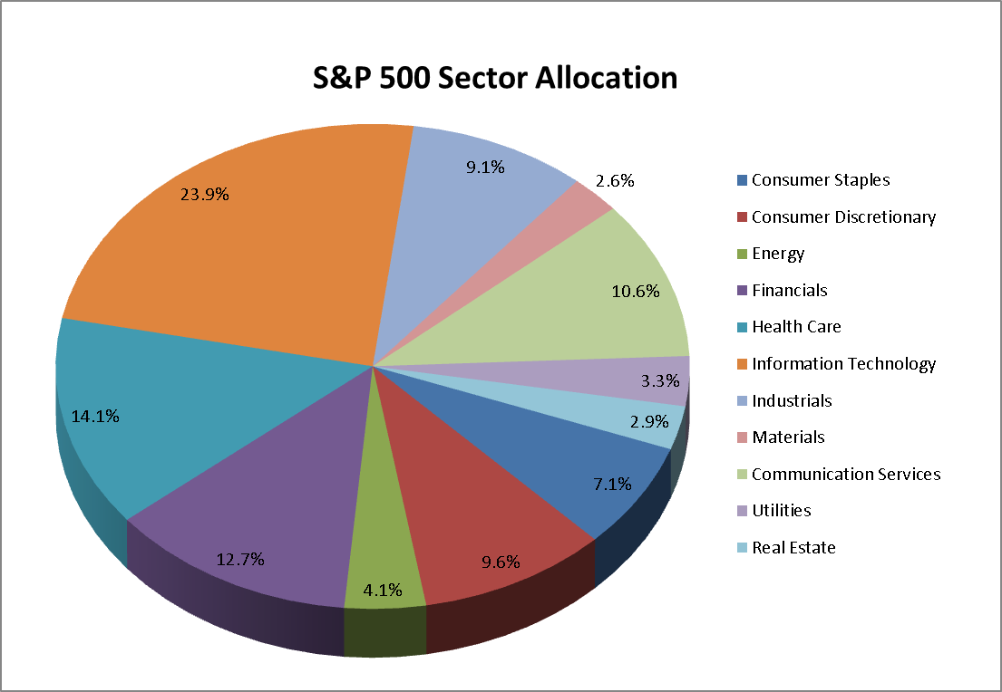
Source: Bloomberg, as of 17 January 2020

The UMAX total return was 2.52% between 20 December 2019 and 17 January 2020 (“January Option Period” or “January Period”). The S&P 500® Index (the “S&P 500” or “Index”) had a total return of 3.82%, in AUD terms, during the same January Period. The Index continued where it left off during the previous December Period, proceeding higher into the end of the year and into the beginning of the 2020 year. The” Santa Claus effect”, mentioned previously where investors buy equities into the end of the year, seemed to continue unabated. Shares signaled a brief pause between the Christmas and New Year holidays, but traded higher after that, reaching new all-time highs in the process. While the end of 2018 and beginning of 2019 will be remembered for high volatility and the Fed taper tantrum, the end of 2019 will be more likely remembered for a lack of volatility and a mostly rosy outlook. Technology shares continued to lead the overall market higher. Apple Inc. (“AAPL”), the largest company in the Index, was the second best performer in the technology sector, returning 14%. All sectors did well during the January Period, with only one sector trading lower. With the market behaving well, volatility continued its trend lower during the January Option Period. The VIX volatility Index ended the January Option Period slightly lower, closing just above 12. The new February 2020 options were written with approximately 97% coverage, 1.7% out-of-the money and to an initial portfolio delta of -0.25.

Information Technology (Index weight: 23.9%)
As it has been many times in the past year, the Information Technology sector was the best performing sector in the Index, increasing 6.8% during the January Option Period. AAPL led the entire sector higher, increasing 14% during the Period. Software stocks also performed well, with all 18 companies in the subsector advancing during the period, 13 of which rose in excess of 5%.
Financials (Index weight: 12.7%)
Financials shares were higher, but nonetheless underperformed the Index during the January Option Period, returning 3.4%. The period ended with a busy earnings season. Wells Fargo & Co. (“WFC”), U.S. Bancorp (“USB”) and Bank of New York Mellon (“BNY”) were the largest disappointments during the latest slew of earnings announcements. The CEO of Wells Fargo blamed

a high cost structure and low interest rates for the disappointing earnings.

Real Estate (Index weight: 2.9%)
The Real Estate sector rebounded somewhat during the January Option Period, increasing 3.3%. After two periods of underperformance, real estate shares started the year on a good note with 28 of the 31 companies in the sector trading higher.

Healthcare (Index weight: 14.1%)
The Healthcare sector gained 2.3% during the January Option Period. The Healthcare sector returns, while still positive, slightly underperformed the Index. This counter performance can be partially attributed to last period’s strong showing when it was the best performing sector in the Index.

Consumer Discretionary (Index weight: 9.6%)
The Consumer Discretionary sector returned 2.9% during the January Option Period, slightly underperforming the overall Index. Auto manufacturers were one of the subsectors that dragged down the overall Consumer Discretionary sector. General Motors Co. (“GM”) and Ford Motor Co. (“F”) both traded lower during the January Period, returning -4.4% and -3.4% respectively.

Industrials (Index weight: 9.1%)
The Industrial sector performed in line with the Index and returned 3.5% during the January Option Period. Transportation shares did well, with nine of the 10 stocks in the subsector increasing during the January Option Period. Five of these names increased in excess of 5%.

Consumer Staples (Index weight: 7.1%)
The Consumer Staples sector traded higher during the January Option Period but underperformed the Index, increasing 1.2%. Beverage manufacturers did well,

however, with all six companies in the subsector posting higher returns during the January Period. Monster Beverage Corp. (“MNST”), Brown Forman Corp. (“BF/B”) and Molson Coors Beverage Co. (“TAP”) all returned in excess of 5% during the same period.

Energy (Index weight: 4.1%)
The Energy sector was once again the worst performing sector in the Index and the only sector to post negative returns during the January Option Period. Energy shares fared poorly during much of 2019, and their fortunes did not seem to turn around as 2020 began. Oil prices and natural gas prices were both lower during the January Period, leading the energy shares lower.

Materials (Index weight: 2.6%)
The Materials sector was the second worst performing sector, after the energy sector, but still managed to increase 0.5% during the January Period. Newmont Corp. (“NEM”), the only gold miner in the sector, outperformed and returned 6.2% during the January Period as gold remained firm.

Communication Services (Index weight: 10.6%)
The Communication Services sector returned 4.5% during the January Option Period. The sector was propelled higher by strong performances from the leading Internet stocks. Facebook Inc. (“FB”) and Alphabet Inc. (“GOOGL”) returned 7.7% and 9.5% respectively.

Utilities (Index weight: 3.3%)
The Utilities sector returned 3.3% during the January Period. Most of the shares in the Utilities sector performed well, with 26 of the 28 components of the sector posting higher returns during the January Period.

The Fund’s equity exposures continue to be obtained indirectly via its holding of one or more US-listed exchange traded funds.

This information has been prepared by BetaShares Capital Ltd (ACN 139 566 868 AFS Licence 341181) (“BetaShares”) the responsible entity of BetaShares S&P 500 Yield Maximiser Fund (managed fund) (the “Fund”) for adviser use only. It is general information only and does not take into account any investor’s objectives, financial situation or needs so it may not be appropriate for an investor’s particular circumstances. Before making an investment decision an investor should consider the product disclosure statement (“PDS”) and their circumstances and obtain financial advice. The PDS is available at www.betashares.com.au. This information is not a recommendation or offer to buy units or adopt any particular strategy. An investment in the Fund is subject to investment risk and the value of units may go down as well as up. Past performance is not an indication of future performance. The performance of the Fund is not guaranteed by BetaShares or any other person. To the extent permitted by law BetaShares accepts no liability for any errors or omissions or loss from reliance on the information herein.
Standard & Poor’s® and S&P® are registered trademarks of Standard & Poor’s Financial Services LLC (“S&P”). These trademarks have been licensed for use by BetaShares. The Fund is not sponsored, endorsed, sold or promoted by S&P or its Affiliates, and S&P and its Affiliates make no representation, warranty or condition regarding the advisability of buying, selling or holding units in the Fund. .

